CLASS: XI-B ACCOUNTANCY DATE: /8/2022
MARKS: 40 PERIODIC TEST -1 TIME: 2 PERIOD
General instructions
Question number 1 to 5 carries 1 mark each.
Question number 6 to 10carries 3 marks each.
Question number 11 and 12 carries 5 marks each.
Question number 13 carry 10 marks. All questions are mandatory

1. The Mathematical Expression defining the comparative relationship between Assets and Liabilities of any person, institution or Business concern is called-
(a) Accounting (b) Accounting Equation
(c) Book – keeping (d) None of these.
2. Liabilities and Assets amount to Rs. 50,000 and Rs. 7,800 respectively. The difference Amount shall represent-
(a) Creditors (b) Debentures
(c) Profit (d) Capital
3. The basis of recording transactions is-
(a) Vouchers (b) Profit
(c) Order form (d) Quotation list.
4. The entry which is passed for bringing forward the balances of personal and Real Account as shown in the last year’s balance sheet is called –
(a) Closing entry (b) Journal entry
(c) Opening entry (d) None of these.
5. Which Account is opened first in ledger book-
(a) Personal (b) Real
(c) Non – real (d) None of these.
6. Why is it necessary for accountants to assume that business entity will remain a going concern concept?
7. State the meaning of business entity
8. Should a transaction be first recorded in a journal or ledger? Why?
9. Why are some accounting systems called double accounting systems?
10. Give a specimen of an account.
11. Prepare accounting equation on the basis of the following:
(a) Sarith started business with cash Rs 2,00,000
(b) Purchased goods from Neema for cash Rs 40,000
(c) Sold goods to Ram costing Rs 10,000/- Rs 12,000
(d) Bought furniture on credit Rs 7,000
12.
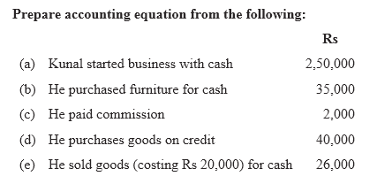
13. Journalise the following transactions in the books of Hari:
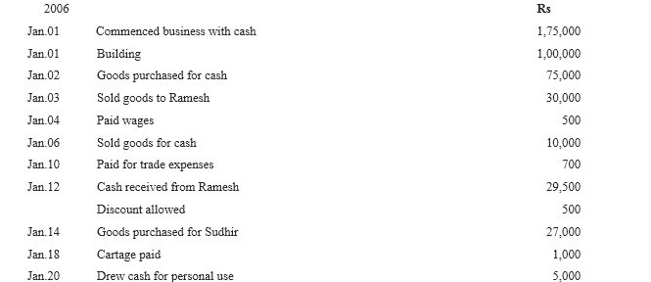

CLASS: XI-B BUSINESS STUDIES DATE: /8/2022
MARKS: 40 PERIODIC TEST -1 TIME: 2 PERIOD
General instructions
All questions are mandatory
Questions from 1to 6 carries 1 mark each
Questions from7 to 10 carries 2 marks each
Question 11 and 12 carries 3 marks each
Question 14 and 15 carries 4 marks each
Question 16 and 17 carries 6 marks each

1. Business refers to an --------------- that basically involves trading of goods and services on a regular basis.

a. economic activity b. primary activity c. commerce d. industry

2. Two business activities which are auxiliaries to trade are-------------- and-------

3. Based on the nature of the activities performed, primary industries can be classified into ‘------------’ or ‘------------ industries.

4. The maximum number of partners allowed in the banking business are
(a) Two (b) Twenty
(c) No limit (d) Ten

5. The structure in which there is separation of ownership and management as per law is called
(a) Company (b) All business organisations
(c) Partnership (d) Sole proprietorship

6. _____________partner is an owner who has unlimited liability and is active in managing the firm:
(a) senior partner. (b) Active partner.
(c) Silent partner. (d) Limited partner.

7. State the different types of economic activities.
8. What are the various types of industries?
9. What is business risk? What is its nature?
10. What factors are important to be considered while starting a business?

11. Mention in brief any two features of sole: proprietorship.
12. Mention in brief the provisions contained in partnership deed?
13. What is the difference between a Joint Stock Company and a Cooperative Society? Explain any three

14. Define business. Describe its important characteristics.
15. Explain any four differences between a private limited company and a public limited company form of business

16. Compare business with profession and employment.
17. Discuss the main types of partners.

